ECOCARDIOGRAFIE TRANSTORACICA
Data examinarii: ..................................
Nume si Prenume: .......................................................... Varsta: ....... ani TA= .................mmHg
Calitatea imaginii ecocardiografice: Buna Satisfacatoare Slaba
Ritm sinusal ⁯ Fibrilatie atriala ⁯ Ritm electrostimulat ⁯
Incidenta parasternala:
Ao la inel: .......................................................... cm (2,2-3,7)
Ao ascendenta: ................................................. cm (2,1-3,4)
Deschidere v ao: ............................................... cm (>1,6)
Apectul valvei aortice: Normal Patologic .........................................................................................
Diam AS: ........................... cm (2,7-4,5)
Diam VD: ................... cm (0,9-2,6)
SIV: ............................ cm (0,6-1,2) Miscare paradoxala SIV: Nu ⁯ Da ⁯
DTDVS: ..................... cm (3,7-5,6)
DTSVS: ...................... cm (2,7-3,7)
PPVS: ......................... cm (0,6-1,2)

FS: .............................. % (25-45)
FE Teichholtz: ............ %
Apectul valvei mitrala: Normal Patologic .........................................................................................
Apical 4 camere: Apical 2 camere:
VTD: .................. ml (95,5 +/-19,4) VTD: .................. ml
VTS: .................. ml (38,6 +/-9,5) VTS: .................. ml
FE planimetric: ............% FE planimetric: ............%
Volum AS: ........................ ml (20-55) Supraf AS :.................... cm² (<20)
Functie diastolica: Normala ⁯ Disfunctie diastolica tip I ; tip II ; tip III ;

Flux mitral: E=............m/s (0,72+/-0,14) A=............m /s (0,40+/-1,10) TDE=...............ms (160-240),
E´=...........m/s, E/E´=.......... , S´=...............ms
Stenoza mitrala Nu Da Severitate: ................................... PHT=............ ms,
Pmed=............ mmHg,
Insuficienta mitrala Nu Da Severitate: ................................... Vena contracta=............ cm
dP/dt= ................. mmHg/ms
Flux aortic : V max=............ m/s, Pmax=............ mmHg, IVT=............ cm,
TEVS=............ cm, IVT TEVS=............ cm,
Stenoza aortica Nu ⁯ Da ⁯ Severitate: ...................................,
AVA cont=............ cm², Splan=............ cm², Pmed=.............. mmHg,
Insuficienta aortica Nu ⁯ Da ⁯ Severitate: ..................................., Vena contracta=............ cm
PHT=................... ms, v td aorta desc=............ cm/s,
Flux tricuspidian: Vmax=............ m/s, P max=............ mmHg
E= ............ m/s (0,51+/-0,07), A=............ m/s (0,27+/-0,08),
Stenoza tricusp Nu ⁯ Da ⁯ Severitate: ..................................., PHT= ..............ms,
Pmed=............ mmHg
Insuficienta tricusp Nu ⁯ Da ⁯ Severitate: ..................................., Vena contracta=............ cm
TAPSE= ...............cm

Flux pulmonar: : Vmax=............ m/s, Pmax=............ mmHg, TaccP=........... ms,
Stenoza pulm Nu ⁯ Da Severitate: ..................................., Pmed=............ mmHg
Insuficienta pulm Nu ⁯ Da ⁯ Severitate: ................................... , PSAP=............ mmHg
Cinetica parietala: Normala ⁯ Anomalii de cinetica parietala
.................................................................................................................................................................................
.................................................................................................................................................................................
apical 4C apical 2C apical 3C GLS = ..............%

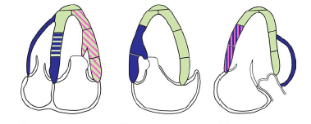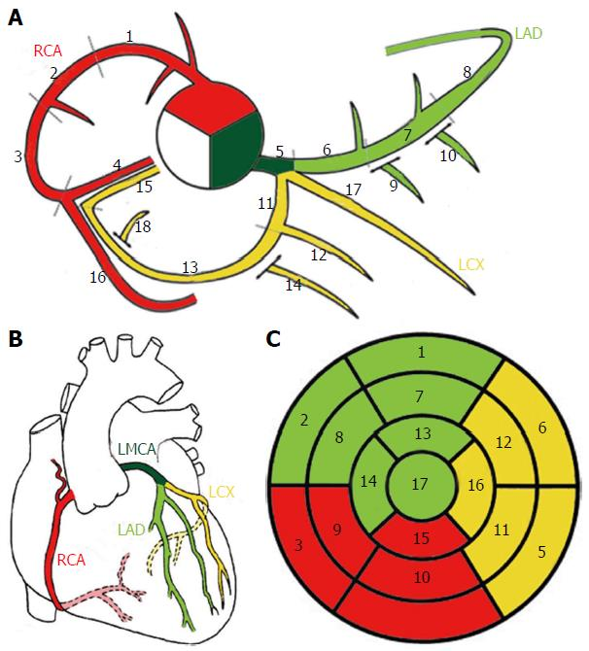
bazal mediu apical
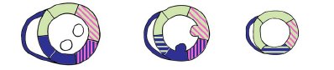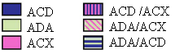
Lichid pericardic: Absent Prezent .........................................................................................
Concluzii:..........................................................................................................................................................................................................................................................................................................................................................................................................................................................................................................................................................................................................................................................................................................................................................................................................................................................................................................
Diagnostice: | Recomandari:
Tratament:
Medic examinator:

